Seller Administrator User Manual

Table of Contents

Registering a Vendor 3

Login Page 3

Register with BidSync Credentials 4

Register from scratch 5

Company Information tab 6

Administrator tab 6

Address tab 7

Terms tab 10

Categories & Certifications tab 10

Commodity/Service Codes tab 15

Locating NIGP Codes using Dropdown 15

Locating NIGP codes using NIGP Code Browse by Category 18

Locating NIGP codes using Keyword Search 21

Summary tab 24

Maintaining a Vendor Profile 25

Notification 25

Homepage 25

Maintaining Organization Information 27

Maintaining General Organization Information 27

Maintaining Addresses 30

Maintaining Commodity Codes & Services 35

Maintaining Regions 46

Maintaining Terms and Categories 46

Maintaining Quote Attachment Repository 49

Accessing Credit Memo List 49

Adding & Maintaining Users on Vendor Account 50

Update Existing Users 51

Add New Users 52

Adding an Associated Organization 54

# Registering a Vendor

The State of Oregon has implemented a new eProcurement system. This new system enables Vendors to connect and do business electronically with the State of Oregon including responding to solicitations and receiving purchase orders online. To view solicitations and submit responses, Vendors must register in OregonBuys.

The purpose of Vendor registration is for the Vendor to provide necessary information to the State of Oregon as a basis to do business with the State of Oregon (referred to subsequently in this guide as "Agency"). As the Vendor representative completes the company's registration, several tabs allow for optional information to be provided (such as Vendor certifications and remit addresses). If the Vendor representative does not have this information on hand during the initial registration process, it may be added later following the completion and acceptance of the initial registration. The Vendor representative is responsible for maintaining the company's account. Following the initial registration process, the Vendor will maintain most if not all of their information online through their newly created account that is established through the registration process.

## Login Page

The purpose of the login page is to provide a publicly accessible point of entry into OregonBuys for the State of Oregon users and Vendors. Vendors may register from the login page, either from scratch or use their BidSync credentials if the Vendor has an existing BidSync account.

### C:\Users\smccaul\AppData\Local\Temp\SNAGHTML1154001.PNGRegister with BidSync Credentials

##### Step 1: Go to OregonBuys.gov

##### Step 2: Click Register

##### Step 3: Enter the BidSync ID and Password and Click Submit BidSync Registration

Much of the Vendor's information outlined below will be pulled from the Bidsync database into the new registration in OregonBuys.

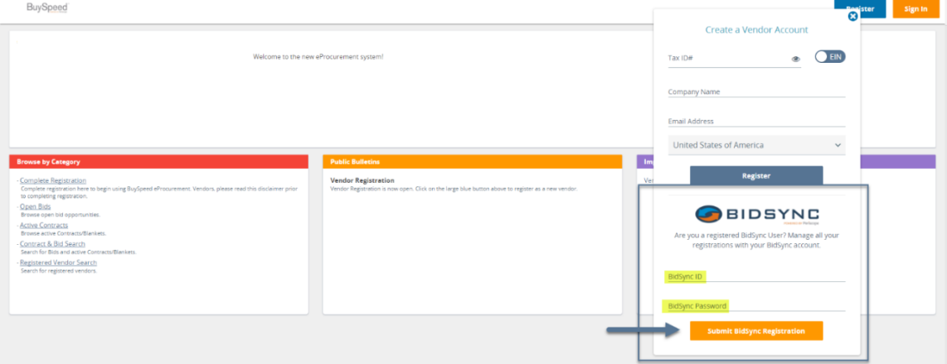

### C:\Users\smccaul\AppData\Local\Temp\SNAGHTML1154001.PNGRegister from scratch

##### Step 1: Go to OregonBuys.gov

##### Step 2: Click Register

##### C:\Users\smccaul\AppData\Local\Temp\SNAGHTML14bac242.PNGStep 3: Enter Baseline Company Data and Click Register

Enter Tax ID, Company Name, and Email Address.

If the Vendor does not have a U.S.-issued Tax ID, the Vendor may change the country by clicking on drop down menu adjacent to the United States of America.

The slide feature next to Tax ID allows the Vendor to indicate that the Tax ID is a Social Security number.

The Vendor receives an initial registration email, containing the Vendor's assigned number. If the Vendor does not complete registration, then the Vendor number is needed to complete the registration at a later date. Use the Complete Registration link on the Homepage to enter the Vendor number and complete the registration.

## Company Information tab

The purpose of the Company Information tab is to capture baseline information on the Vendor such as their mailing address.

##### Step 1: Complete Required Fields

The Company Email address is used to notify Vendors of opportunities (Bids and other solicitations). Some Vendors develop an email re-direct/distribution protocol to distribute such notifications to their salesforce.

##### Step 2: Complete Optional Fields as preferred

##### C:\Users\smccaul\AppData\Local\Temp\SNAGHTML1335ae1.PNGStep 3: Click Save & Continue Registration

## Administrator tab

The purpose of the Administrator tab is to capture data on the Vendor's key administrative user. Upon completion of registration, this user will have control of the Vendor's account including the ability to add additional users, edit existing data, and add profile attachments and forms.

##### Step 1: Complete Required Fields

##### Step 2: Complete Optional Fields as preferred

If registration was initiated with BidSync credentials, then the Bidsync fields on this page will not display. The new BuySpeed account will be linked to the user's existing BidSync account.

If the registration was initiated from scratch, the Vendor should leave the BidSync username and password fields blank. A new BidSync account is established for the Vendor based on the information provided during the registration process in OregonBuys.

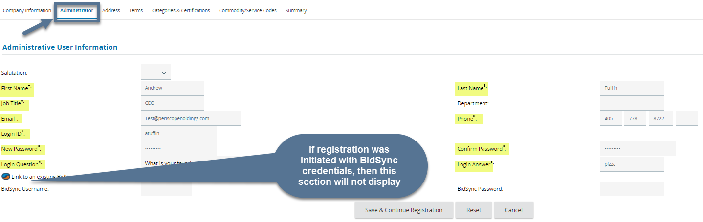If the Vendor has a BidSync account (but did not initiate registration with BidSync credentials), the Vendor should enter their BidSync Username and Password. Once registration is complete, the user's new BuySpeed account will be linked to their BidSync account.

##### Step 3: Click Save & Continue Registration

## Address tab

The purpose of the Address tab is to capture the Vendor's addresses for notification of solicitation opportunities, purchasing, and payment uses. The initial data the Vendor input on the Company Information tab will be used to create the Vendor's General Mailing Address.

##### Step 1: Click Add Another Address

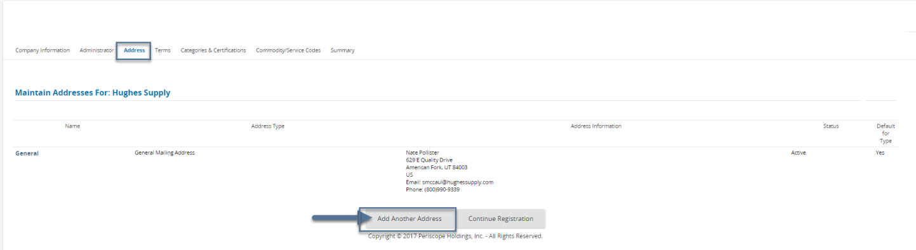

##### Step 2: Select Address Type from the Dropdown Menu

The Address Type designates where notification and payments are delivered. If no other addresses are added, then all notifications and payments go to the general mailing address.

|  |  |  |  |
| --- | --- | --- | --- |
| **Address Type** | **Field Description** | **Field Implication** | **Common Usage** |
| Bid Mailing Address | Physical and email address for Bid notifications | Solicitation opportunities sent to default Bid Mailing email address | Group or shared email frequently used |
| PO Mailing Address | Physical and email address for PO notifications | PO notifications sent to default PO Mailing email address | Group or shared email frequently used |
| Remit Address | Physical and email address for payments (some may be EFT-enabled)  **This address is imported from the State’s financial system, do not create.** | Payments sent to Remit Address or via EFT | Group or shared email frequently used |

##### C:\Users\smccaul\AppData\Local\Temp\SNAGHTML14c10d26.PNGStep 3: Complete Required Fields

##### Step 4: Complete Optional Fields as preferred

##### Step 5: Click Save & Continue Registration or Save & Add Another

## Terms tab

The purpose of the Terms tab is to identify preferred Vendor terms. The terms may be overridden by the procurement group.

##### Step 1: Click the dropdown menu to select a term

##### Step 2: Continue to select Terms as preferred

##### Step 3: Click Save & Continue Registration

## Categories & Certifications tab

The purpose of the Categories & Certifications tab is to capture demographic information and related certifications that are not otherwise included in the Company Information tab.

##### Step 1: Click the appropriate values for each Vendor category, as applicable

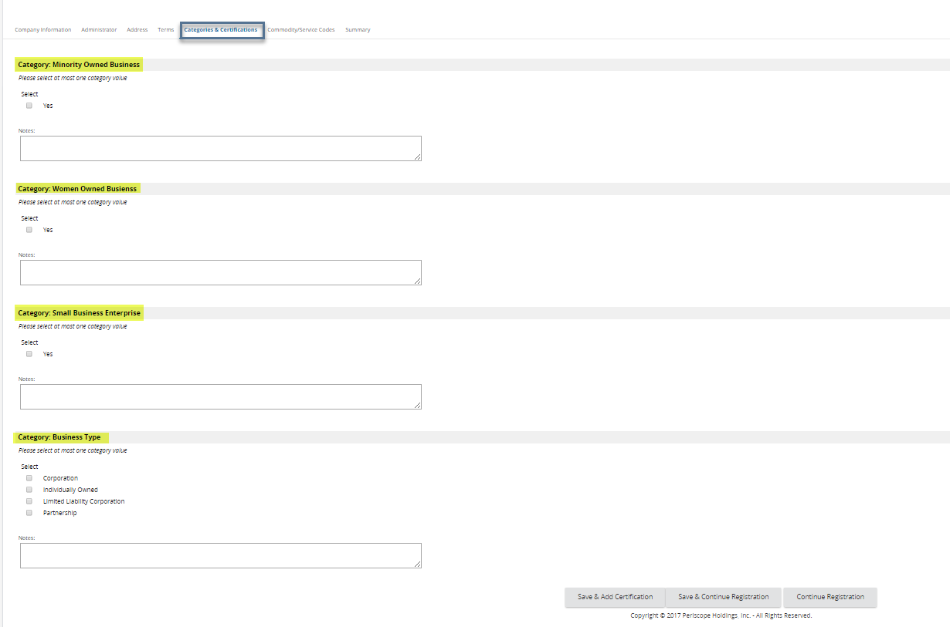The State of Oregon requires an agreement to the Terms of Use. All other Vendor categories (Disadvantage Business Enterprise, Service Disabled Veteran Business Enterprise, etc.) are configured in COBID (Certification Office for Business Inclusion and Diversity). To apply for certification for one of these categories, go to [http://www.oregon4biz.com](http://www.oregon4biz.com/).

##### Step 2: Click Save & Add Certification

Vendor categories may have associated certifications. For example, if the Vendor identified as a small business, then the Vendor may provide the certification information at this time.

Any Vendor category that permits entry of certification data will display an Add Certification link beside the value.

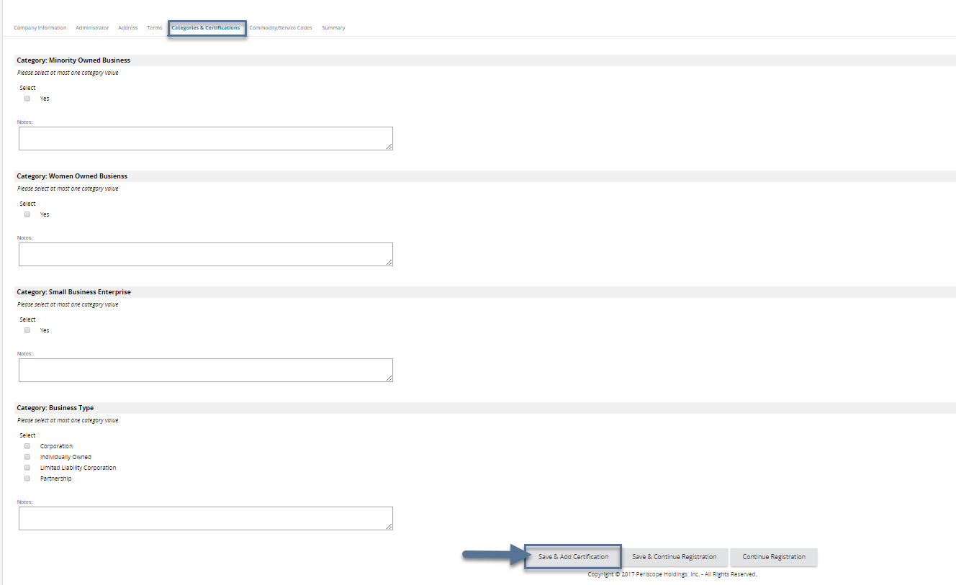

##### Step 3: Click Add Certification, as applicable

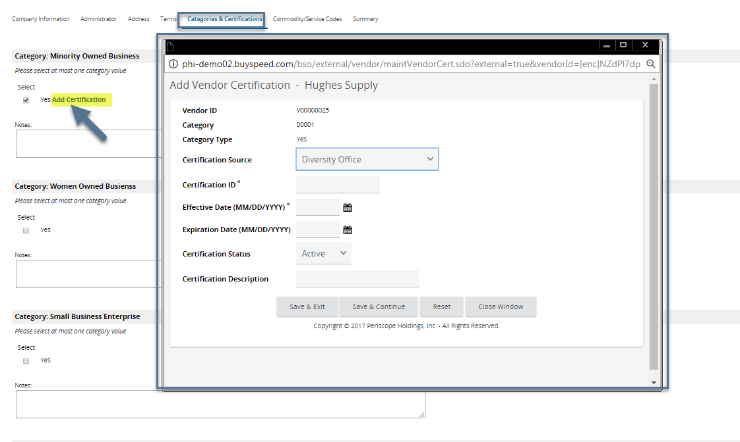A new pop-up window for data entry will now appear to the Vendor.

##### Step 4: Enter Certification data, as appropriate

The Vendor should input all the appropriate data associated with a certification including the selection of the certification source from the dropdown menu.

##### Step 5: Click Save & Exit

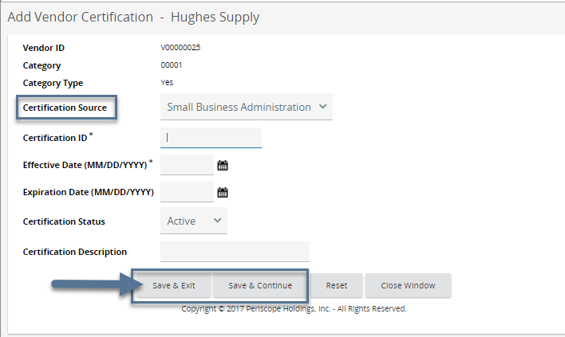The Vendor may click Save & Continue to continue updating the certification information. Save & Exit will return the Vendor to the registration.

##### Step 6: Click Save & Continue Registration

## Commodity/Service Codes tab

The purpose of the Commodity/Services Codes tab is to capture the commodity codes for which the Vendor would like to receive electronic notification of solicitation opportunities. The commodity codes identify the products and services the Vendor provides. Depending on the Vendor's familiarity with the NIGP code, the Vendor may choose from one of three ways to add NIGP codes.

### Locating NIGP Codes using Dropdown

For the Vendor most familiar with the NIGP code, the system allows the Vendor to select specific NIGP class and NIGP class item codes. First, the Vendor selects the 3-digit NIGP class code, which populates the second dropdown with 2-digit NIGP class item codes.

##### Step 1: Select NIGP Class from Dropdown Menu

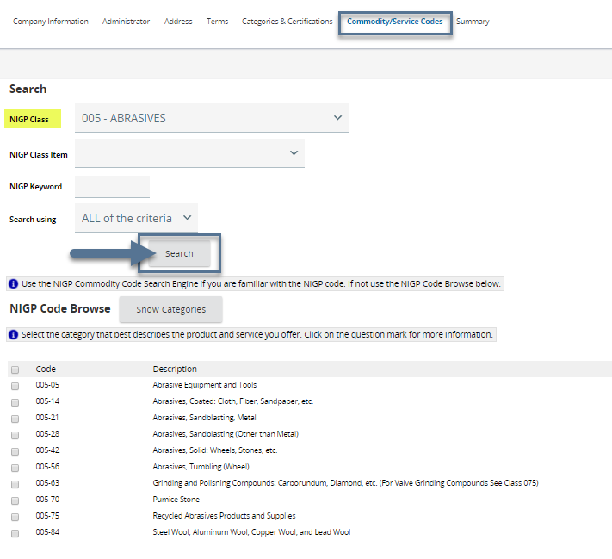

##### Step 2: Select Class Items by Clicking Appropriate Checkboxes

The checkbox next to "Code" allows the Vendor to select all class items with a single click.

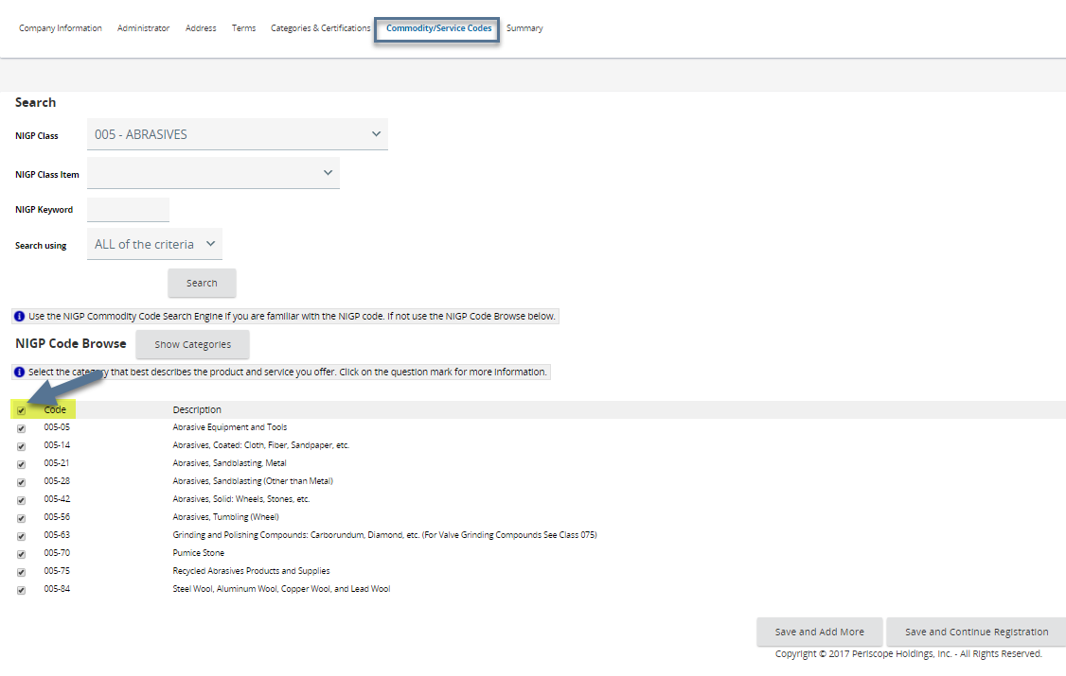A good practice for many Vendors is to select all NIGP class items within a class. This practice will allow the Vendor to maximize notifications of future solicitation opportunities.

##### Step 3: Click Save and Continue Registration

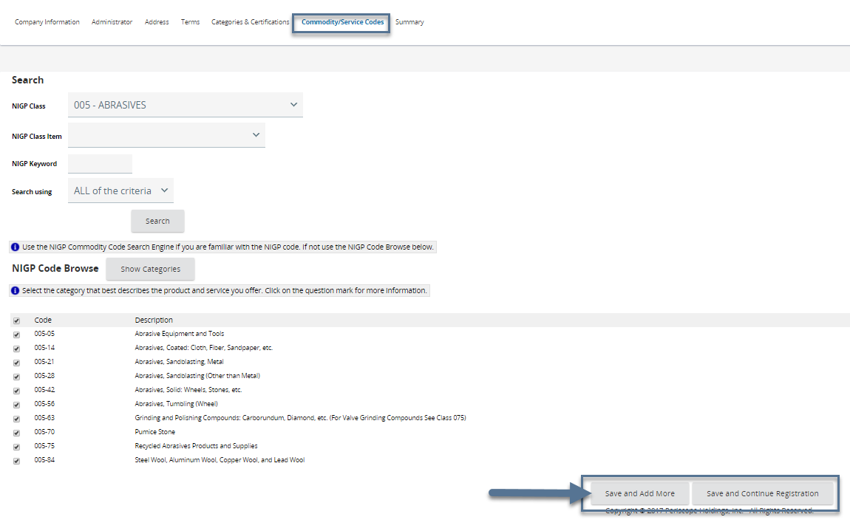To add commodity codes in one class, click Save and Continue Registration. To add more commodity codes, click Save and Add More. If the Save and Add More option is clicked, the Vendor will be returned to the main commodity code search screen.

### Locating NIGP codes using NIGP Code Browse by Category

If the Vendor is less familiar with the NIGP code, another option is the NIGP Code Browse.

##### Step 1: Scroll Down to NIGP Code Browse

##### Step 2: Review Categories and Click the Category Number

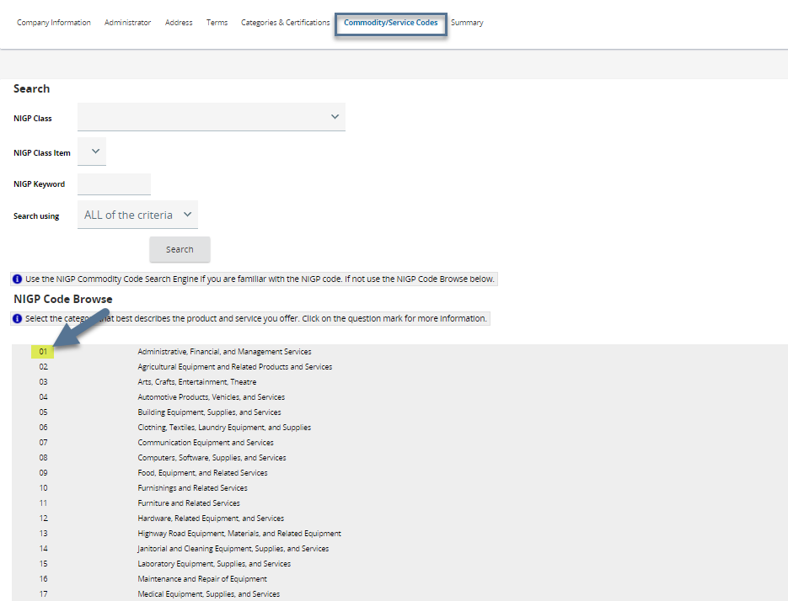The 2-digit categories are based on the descriptions of goods and services. Once the category number is clicked, all the NIGP classes under the category display.

##### Step 3: Click the NIGP Class Number (3 digits)

##### Step 4: Select Class Items by Clicking Appropriate Checkboxes

##### Step 5: Click Save and Add More or Save and Continue Registration

### Locating NIGP codes using Keyword Search

The final option to add commodity codes to the Vendor profile is the NIGP Keyword Search. While this method may be effective when searching for discrete terms (e.g., bandage), the search function may return a large number of NIGP class items. The Vendor should use this search function in combination with the NIGP Code Browse function to find appropriate class items in an efficient manner.

##### Step 1: Enter Keyword(s)

##### Step 2: Click Search

##### Step 3: Select Class Items by Clicking Appropriate Checkboxes

##### Step 4: Click Save and Add More or Save and Continue Registration

## Summary tab

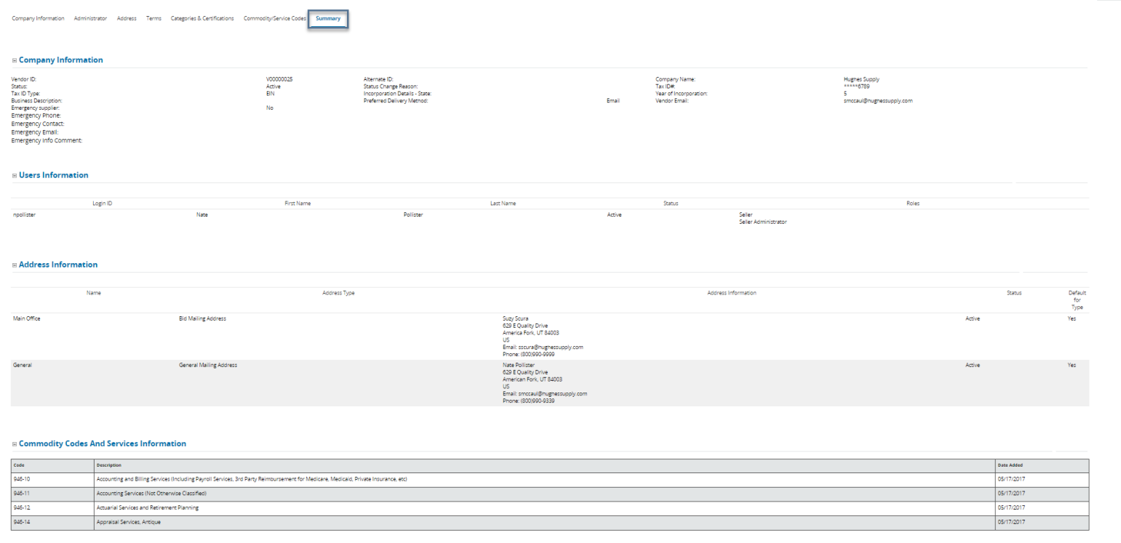The Summary tab provides an overview of the information provided by the Vendor on the previous tabs. The Vendor should review the information before submitting the registration. The Vendor may return to any previous tab to modify information simply by clicking on the specific tab.

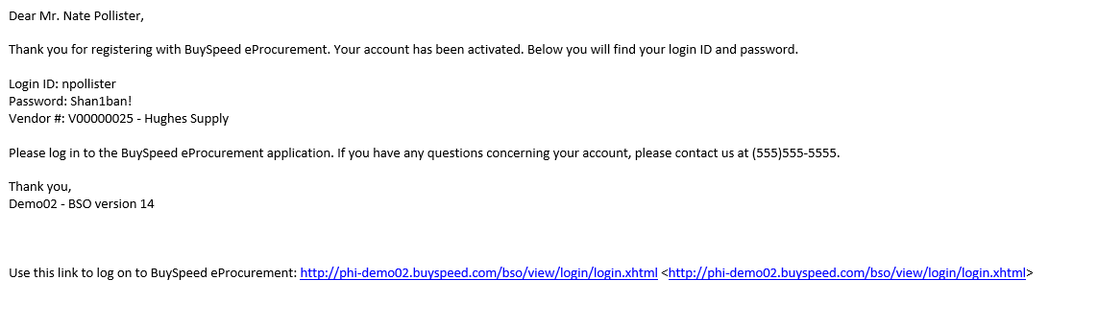Once the Vendor is satisfied with all the information on the registration, click the Complete Registration button. A thank you for registering confirmation message is displayed. The Vendor will receive a confirmation email message from OregonBuys that their account has been activated. The Vendor may then log in to OregonBuys to add or update any information.

# Maintaining a Vendor Profile

Once registered in OregonBuys, a Vendor in the Seller Administrator role can log in and update many of the components of their Vendor profile including:

* General Information such as email address and emergency Vendor information
* Addresses
* Terms, Categories & related Certifications
* Commodity Codes

In addition, the Vendor may add or delete user and add Associated Organizations (often referred to as "Doing Business As" Vendors).

The purpose of Vendor profile maintenance is to ensure that the State of Oregon (referred to subsequently in this guide as "Agency") has the most current information for the Vendor. The maintenance of the profile also ensures that the appropriate users have access to respond to Solicitations, to receive Purchase Orders and to submit Invoices (if configured by the Agency).

## Notification

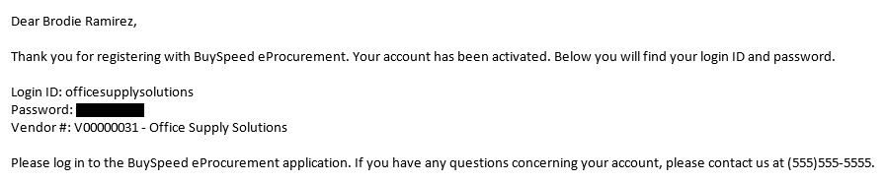The Vendor will receive an email from the system notifying the new Seller Administrator (the Vendor's account "owner") that registration is complete/active. The email is sent to the email address on the General Organization Information tab.

## Homepage

The purpose of the Seller Administrator Maintenance Homepage is to provide a dashboard for the Seller Administrator in OregonBuys, to access sections of the profile, such as users and general organization information.

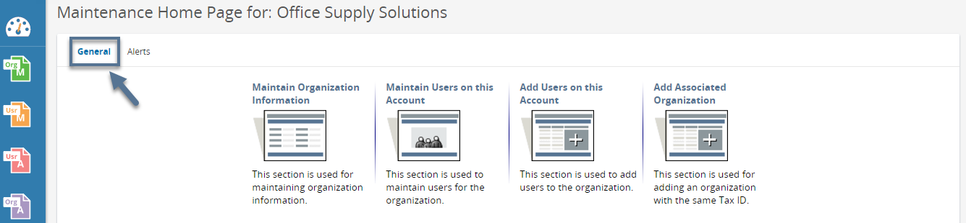Once logged in, the Seller Administrator will land on the General tab of the Maintenance Home Page. If the user's Homepage does not look like the one shown below, the user is probably in the Seller role (which is also created for the first user on the Vendor's account). To change roles, follow the steps shown below the screenshot.

##### Step 1: Click the User Account Icon in the upper right of the Homepage

##### Step 2: Click the down arrow under the user name

##### Step 3: Scroll down and select Seller Administrator

## Maintaining Organization Information

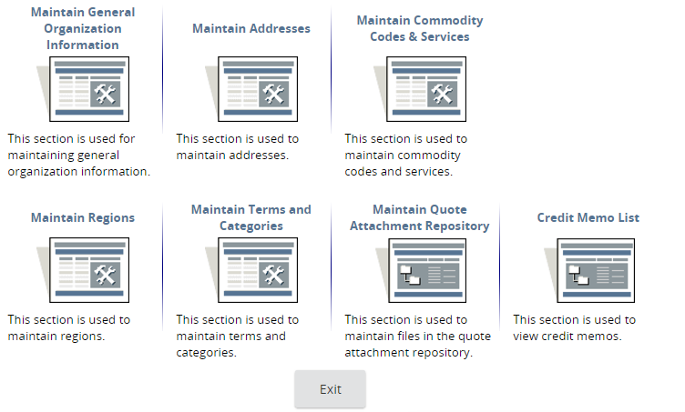The purpose of this section is to allow Seller Administrators to update data regarding the Vendor organization such as Addresses, Commodity Codes, and Terms and Categories.

### Maintaining General Organization Information

The purpose of this section is to allow Seller Administrators to update general information regarding the Vendor organization such as the incorporation details, business description, email address, preferred delivery method, primary contact information and emergency supplier status.

Note: The Vendor email address shown on this portion of the Vendor profile is used to notify the Vendor of opportunities (Bids and other solicitations). Some Vendors develop an email re-direct/distribution protocol to distribute such notifications to their salesforce.

##### Step 1: From the General tab, click Maintain Organization Information

##### Step 2: Click Maintain General Organization Information

##### Step 3: Update required and optional fields as needed

The Seller Administrator can upload or delete Attachments on this screen as well as add Forms, if enabled for the Vendor.

##### Step 4: Click Save and Exit

The Seller Administrator can click Save & Continue to save the changes and to remain on the page. To undo the changes click Reset or click Cancel & Exit to exit the page without saving the changes.

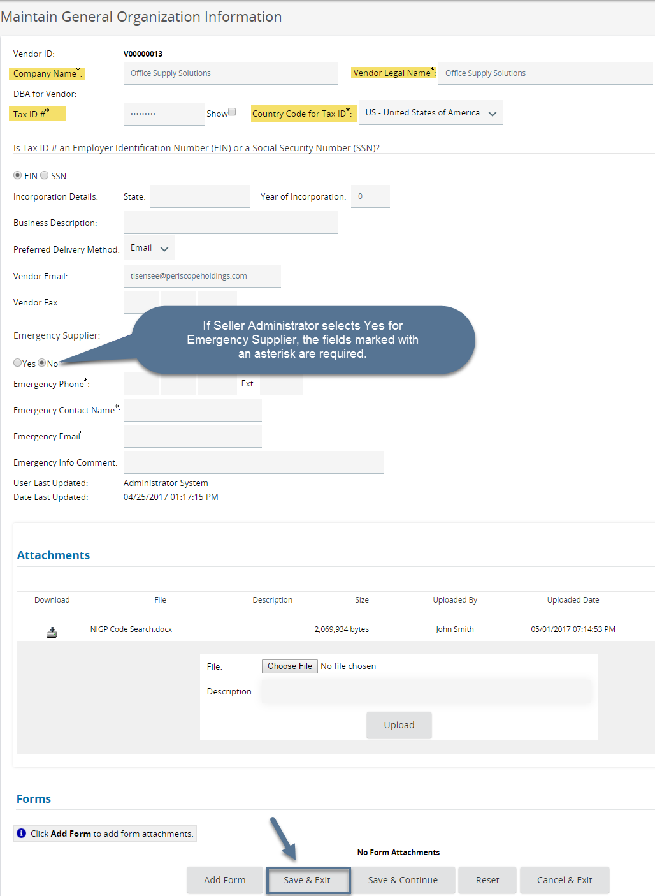

### Maintaining Addresses

The purpose of this section is to allow the Seller Administrator to maintain all of the addresses associated with the Vendor's account. It is important for the Seller Administrator to keep these addresses up to date. Types of addresses may include General Mailing Address, Bid Mailing Address and Purchase Order Mailing Address.

The address that appears for the General Mailing Address is the address that the Vendor entered when first registering. This email address is used for notifications of bidding and other solicitation opportunities. However, if the Vendor establishes a default Bid Mailing Address, the Buyer may select this address for the Bid, and the bid notification will be sent to the email address associated with that Bid Mailing Address.

|  |  |  |  |
| --- | --- | --- | --- |
| **Address Type** | **Field Description** | **Field Implication** | **Common Usage** |
| Bid Mailing Address | Physical and email address for Bid notifications | Solicitation opportunities sent to default Bid Mailing email address | Group or shared email frequently used |
| PO Mailing Address | Physical and email address for PO notifications | PO notifications sent to default PO Mailing email address | Group or shared email frequently used |
| Remit Address | Physical and email address for payments (some may be EFT-enabled) | Payments sent to Remit Address or via EFT | Group or shared email frequently used |

#### Add New Address

##### Step 1: Click Maintain Addresses

##### Step 2: Click Add Another Address

##### Step 3: Complete Required and Optional Fields as preferred

##### Step 4: Click Save & Exit

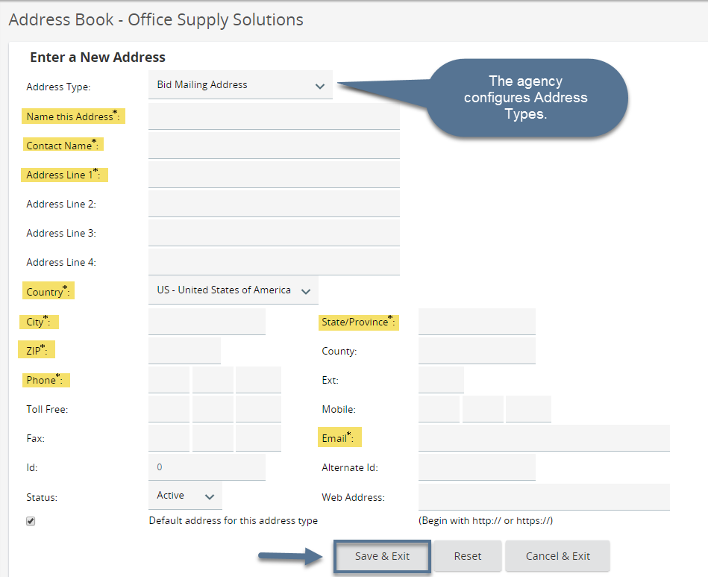The Address Types allowed are maintained by the Agency. The Vendor can click Reset to erase entered data or click Cancel & Exit to exit the screen without saving.

#### Update an Existing Address

##### Step 1: Click Maintain Addresses

##### Step 2: Click the Address Name

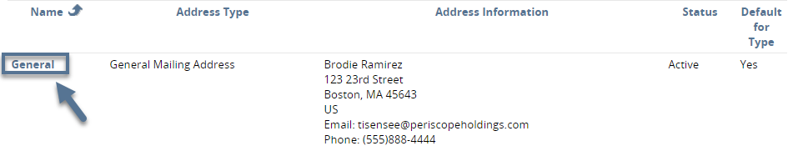

##### Step 3: Update Required and Optional Fields as needed

The Seller Administrator can update the Status of the Address to Inactive so that the address will not display on the Agency side.

##### Step 4: Click Save & Exit

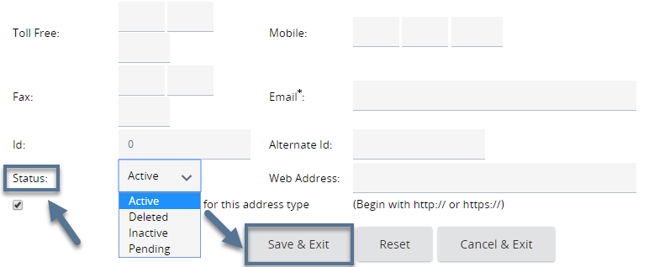The Seller Administrator can click Reset to undo the updated data or click Cancel & Exit to exit the page without saving the changes.

#### Add EFT Information to a Remit Address

Seller Administrators may add EFT information to a Remit Address to receive electronic payments for Invoices (if enabled by the Agency). This information is encrypted in the database after it is saved. The Seller Administrator may add EFT to an existing Remit address (see section above) or add a new Remit address and add EFT information to it.

##### Step 1: Click Add Another Address

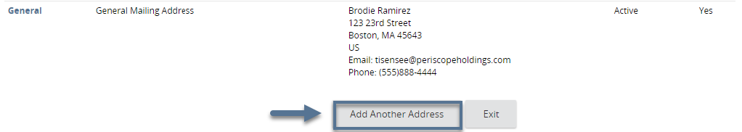

##### Step 2: Select Remit Address as the Address Type

##### Step 3: Complete Required Fields

##### Step 4: Select EFT Enabled

##### Step 5: Complete Required Fields under EFT Enabled

##### Step 6: Click Save & Exit

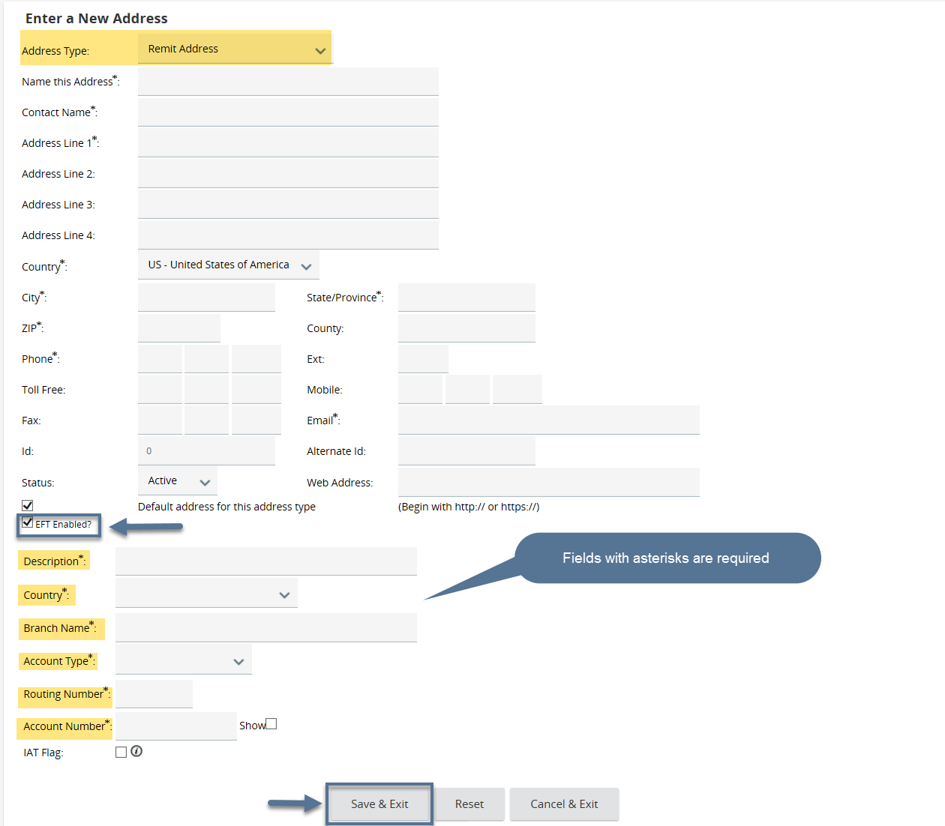The Seller Administrator can click Reset to undo the entered information or click Cancel & Exit to exit the page without saving.

### Maintaining Commodity Codes & Services

The purpose of this section is to allow the Seller Administrator to update the NIGP codes, which determine which Bid opportunities the Vendor is notified of via email from the system. The Seller Administrator must keep this up to date as the Agency can add all Vendors listed under a certain NIGP code for a Solicitation. Depending on the Seller Administrator's familiarity with the NIGP code structure, the user may choose from one of three ways to add NIGP codes.

#### Add Additional Codes Using Dropdown

If the Seller Administrator is familiar with the NIGP code, the system allows the user to find and select specific codes to add.

##### Step 1: Click Maintain Commodity Codes & Services

##### Step 2: Click Maintain Commodity Codes

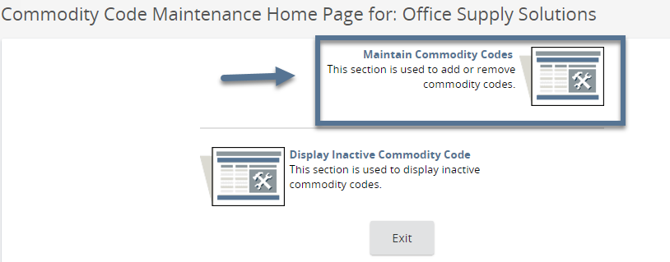

##### Step 3: Click Add Additional Codes

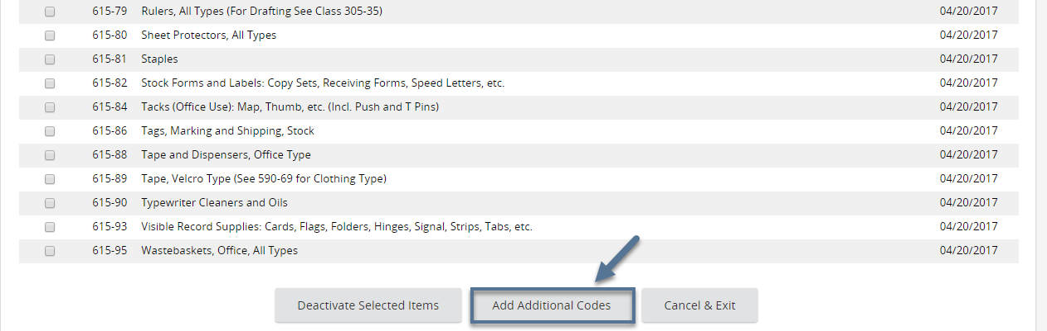The codes that appear on this page are the NIGP codes that the Vendor listed when first registering in the system.

##### Step 4: Select NIGP Class from Dropdown Menu

First the Seller Administrator selects the 3-digit NIGP class code, which populates the second dropdown with 2-digit NIGP class item codes.

##### Step 5: Select Class Items by Clicking Appropriate Checkboxes

The checkbox next to "Code" allows the Seller Administrator to select all class items with a single click.

A good practice for many Vendors is to select all class items within a class. This practice allows the Vendor to maximize notifications of future solicitation opportunities.

##### Step 6: Click Save

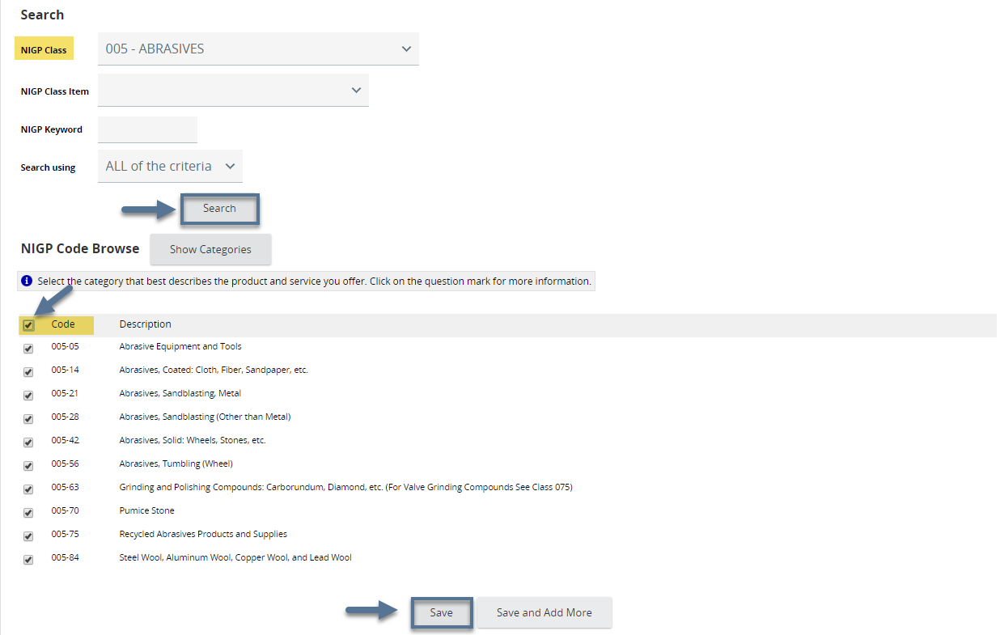

To add more commodity codes, click Save and Add More. If the Save and Add More option is clicked, the Seller Administrator will be returned to the main commodity code search screen.

#### Add Additional Codes Using NIGP Code Browse by Category

If the Seller Administrator is less familiar with the NIGP code, another option is the NIGP Code Browse.

##### Step 1: Click Maintain Commodity Codes & Services

##### Step 2: Click Maintain Commodity Codes



##### Step 3: Click Add Additional Codes

The codes that appear on this page are the NIGP codes that the Vendor listed when first registering in the system.



##### Step 4: Scroll Down to NIGP Code Browse

##### Step 5: Review Categories and Click the Category Number

The categories are based on the descriptions of goods and services. Once the category number is clicked, all the NIGP classes under the category display.

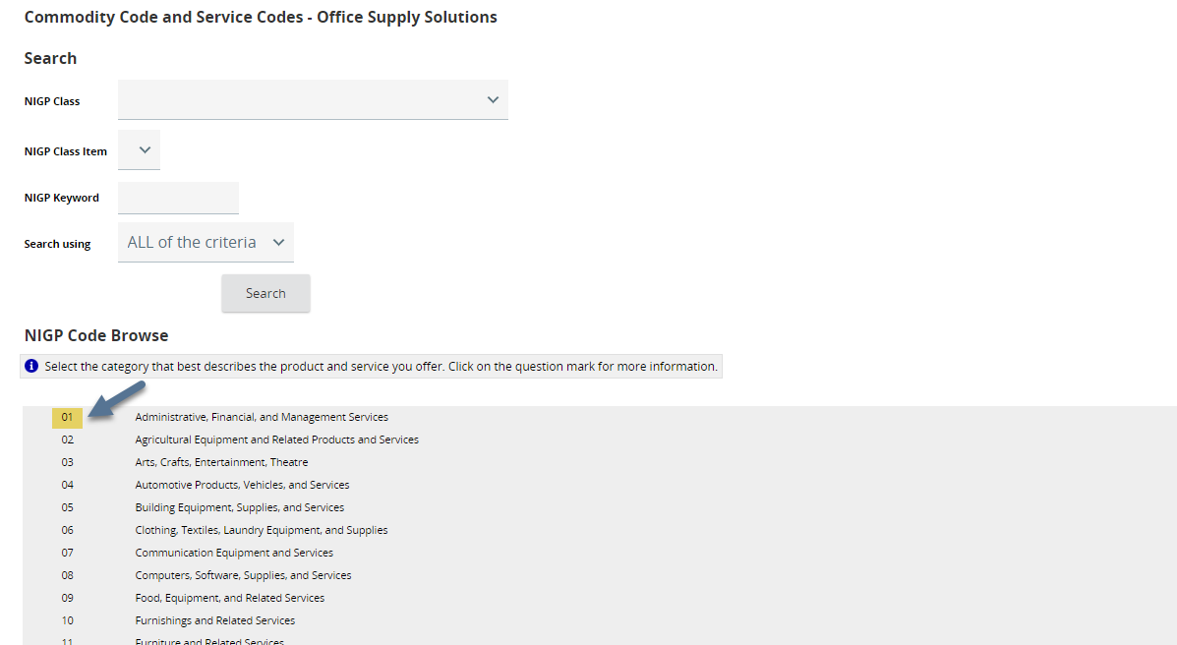

##### Step 6: Click the NIGP Class Number (3 digits)

##### Step 7: Select Class Items by Clicking Appropriate Checkboxes

##### Step 8: Click Save or Save and Add More

#### Add Additional Codes Using Keyword Search

The final option to add commodity codes to the Vendor profile is the NIGP Keyword Search. While this method may be effective when searching for discrete terms (e.g., bandage), the search function may return a large number of NIGP class items. The Seller Administrator should use this search function in combination with the NIGP Code Browse function to find appropriate class items in an efficient manner.

##### Step 1: Click Maintain Commodity Codes & Services

##### Step 2: Click Maintain Commodity Codes

##### Step 3: Click Add Additional Codes

The codes that appear on this page are the NIGP codes that the Vendor listed when first registering in the system.

##### Step 4: Enter Keyword(s)

##### Step 5: Click Search

##### Step 6: Select Class Items by Clicking Appropriate Checkboxes

##### Step 7: Click Save or Save and Add More

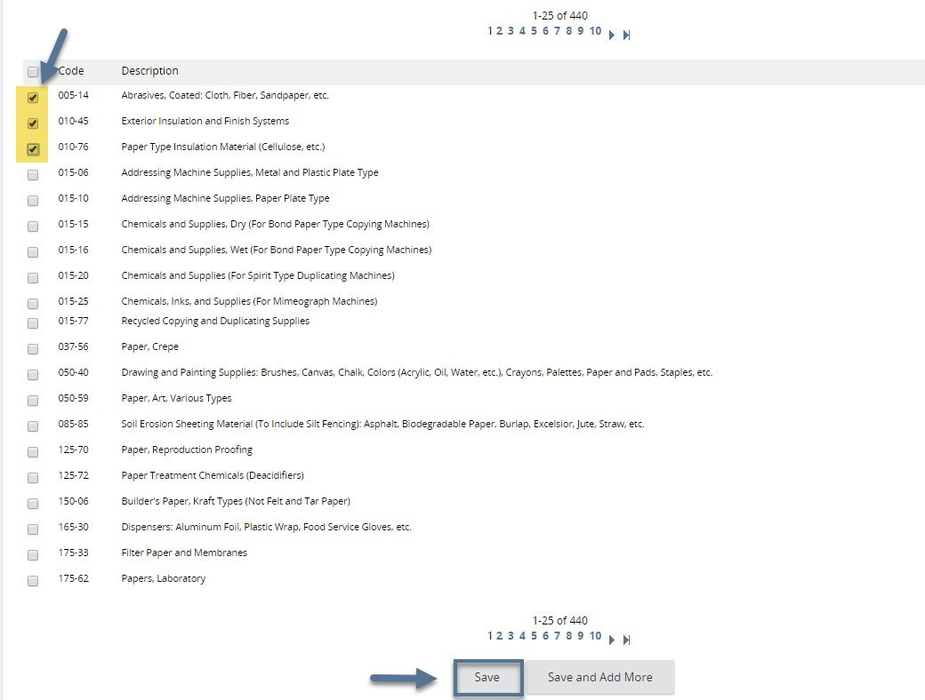

#### Deactivate Codes

##### Step 1: Click Maintain Commodity Codes & Services

##### Step 2: Click Maintain Commodity Codes

##### Step 3: Select the Code(s) to Deactivate

##### Step 4: Click Deactivate Selected Items

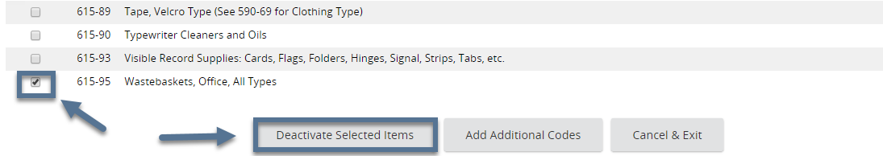The Seller Administrator can click Deactivate Selected Items to deactivate the selected codes. Or simply click Cancel & Exit to exit the page without deactivating the selected codes.

#### Reactivate Inactive Codes

##### Step 1: Click Maintain Commodity Codes & Services

##### Step 2: Click Display Inactive Commodity Codes

##### Step 3: Select the Code(s) to Activate

##### Step 4: Click Save & Exit

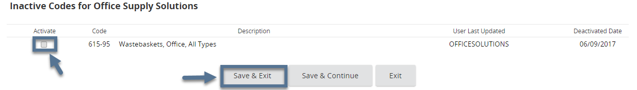The Seller Administrator can click Save & Continue to save the changes and to remain on the page. The Seller Administrator can click Exit to exit without saving the change.

### Maintaining Regions

This section is no longer used.

### Maintaining Terms and Categories

The purpose of this section is to allow the Seller Administrator to update demographic information (Vendor Categories), related certifications and terms.

##### Step 1: Click Maintain Terms and Categories

##### Step 2: Complete Required and Optional fields as needed

The Terms and the Categories are configured by the Agency.

##### Step 3: Click Save & Continue

When the Seller Administrator clicks Save & Continue, any Vendor Categories that have underlying Certifications associated with them will display an Add Certification link. This link may be clicked to add certification information associated with that Vendor Category.

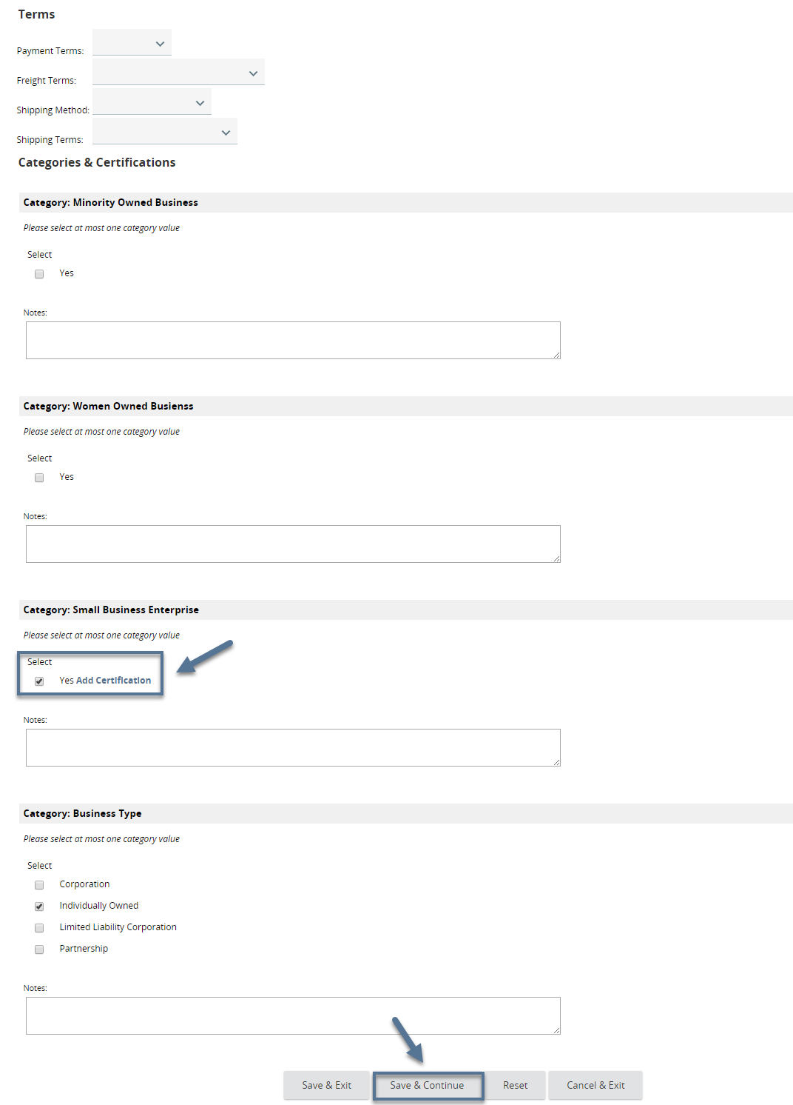

##### Step 4: Click Add Certification, as applicable

A new window opens for data entry.

##### Step 5: Enter Certification data, as appropriate

The Seller Administrator should input all the appropriate data associated with a certification including the selection of the certification source from the dropdown menu.

##### Step 6: Click Save & Exit

The Seller Administrator may click Save & Continue to continue updating the certification information. Save & Exit will return to the Terms, Categories, and Certifications page.

##### Step 7: Click Save & Exit (on the main Terms, Categories, and Certifications page)

The Seller Administrator can click Reset to undo the entered data or click Cancel & Exit to exit from the page without saving.

### Maintaining Quote Attachment Repository

This section is no longer used.

### Accessing Credit Memo List

The purpose of this section is to allow the Seller Administrator to view any existing Credit Memos that may be applied to payments in the future. The Credit Memos that are shown will have been previously entered into the system by an Accounts Payable user in the Agency.

##### Step 1: Click Credit Memo List

##### Step 2: View Credit Memos

The Seller Administrator can view the Credit Number, the description, the department and location, status, credit amount and the date of each Credit Memo.

##### Step 3: Click Exit

## Adding & Maintaining Users on Vendor Account

The purpose of this section is to allow the Seller Administrator to update existing users on the Vendor's account. The Seller Administrator can add users from Add Users on this Account.

### Update Existing Users

##### Step 1: Click Maintain Users on this Account

##### Step 2: Click Login ID

##### Step 3: Update Required and Optional Fields as needed

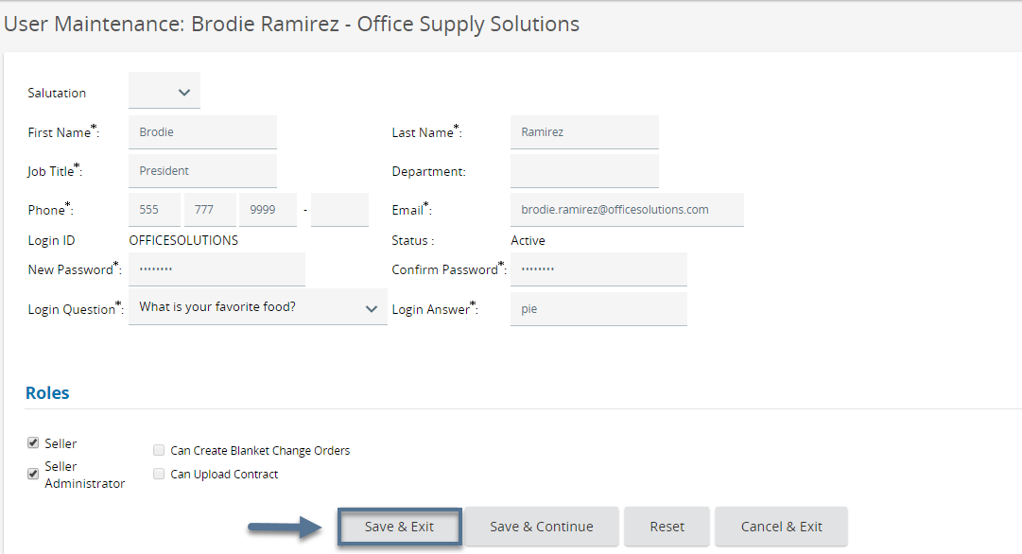The initial registrant in the system must have the Seller Administrator role. This cannot be changed.

##### Step 4: Click Save & Exit

The Seller Administrator can click Save & Continue to save the changes on the page and remain on the page. Click Reset to undo the changes or click Cancel & Exit to exit out of the page without saving the changes.

### Add New Users

The purpose of this section is to allow the Seller Administrator to create additional users on the Vendor account. The Seller Administrator can also create users from Maintain Users on this Account.

##### Step 1: Click Add Users on this Account

##### Step 2: Complete Required and Optional Fields per preference

The Seller Administrator must complete the fields marked with an asterisk. The Seller Administrator user should not put in BidSync username and password if the new vendor user does not have one.

##### Step 3: Click Save & Exit

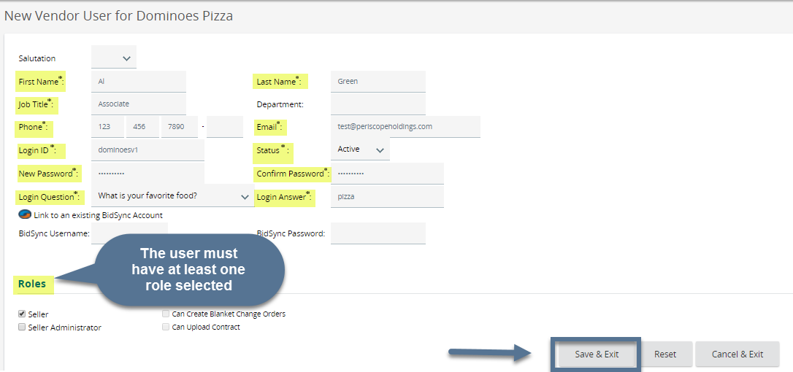The Seller Administrator can click Reset to erase the entered data or click Cancel & Exit to exit the page without saving.

The two roles and role privileges are described in the table below.

|  |  |  |
| --- | --- | --- |
| User Role/Privilege | Description | Recommended Usage |
| Seller | User may view and acknowledge Bid opportunities including Bid Amendments; may submit responses to Bids (Quotes); may acknowledge POs and PO Change Orders; may create/submit Invoices | Appropriate role for members of the Vendor’s salesforce and/or Accounts Receivable staff (if using Invoice features) |
| Seller Administrator | User has full access to administrative functions of Vendor account; may update General Information, Addresses, Vendor Categories/Certifications and Commodity/Service codes; may add and inactivate users on account; may view Credit Memo list; may add a DBA Vendor | Should be limited to authorized personnel to improve control of information |
| Can Create Blanket Change Orders (if enabled by Agency) | Seller ONLY feature: may initiate a Change Order to a Master Blanket PO (that will require approval by the contract "owner" of the Agency) | Varies depending on internal responsibilities |
| Can Upload Contract (if enabled by Agency) | Seller ONLY feature: may upload items to a contract (Master Blanket PO) | Varies depending on internal responsibilities |

## Adding an Associated Organization

The purpose of this section is to allow the Seller Administrator to initiate the registration for an associated organization in the system under the Vendor's Tax ID. This is often used by Vendors to register a DBA, "Doing Business As" entity.

##### Step 1: Click Add Associated Organization

##### Step 2: Complete required and optional fields as appropriate

On the Send Mail screen the Seller Administrator must complete the fields marked with an asterisk. Send Mail is used to request that the associated organization registers in OregonBuys.

##### Step 3: Click Send

The user can click Cancel & Exit to exit out of the page without sending the email.

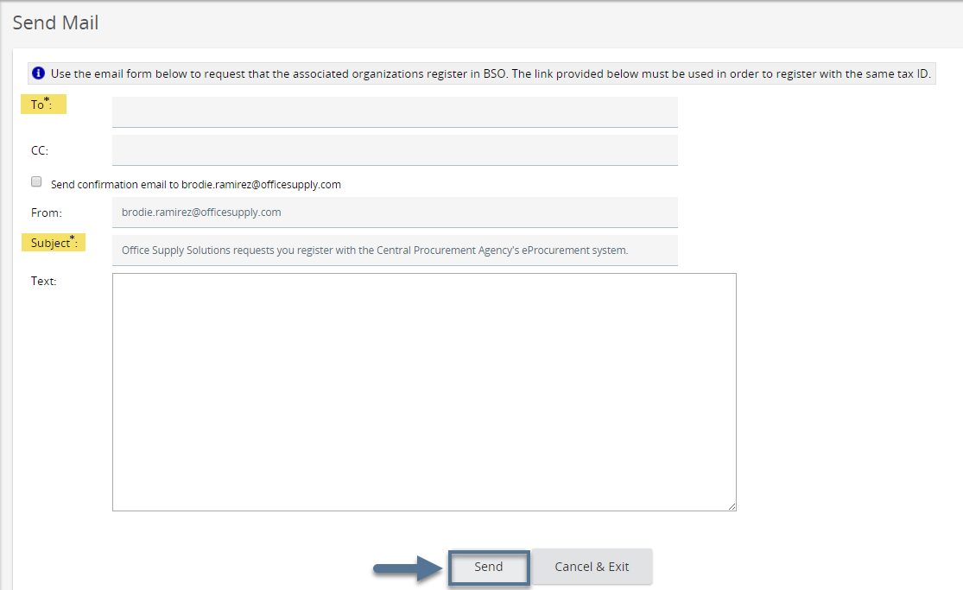

##### Step 4: Click OK

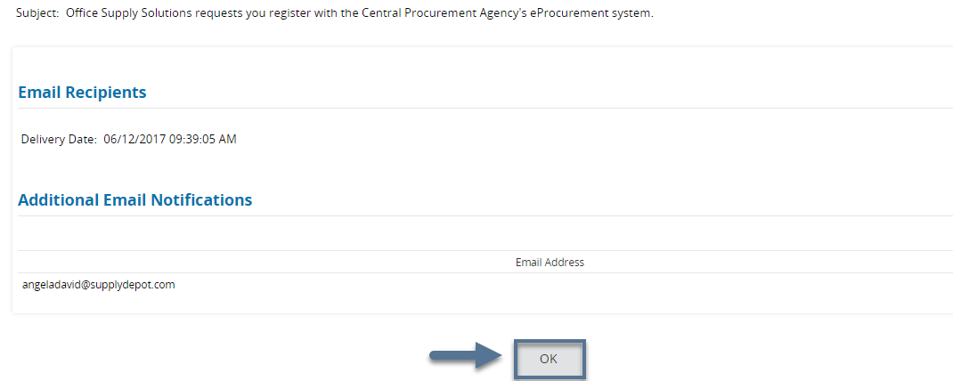An email confirmation displays.